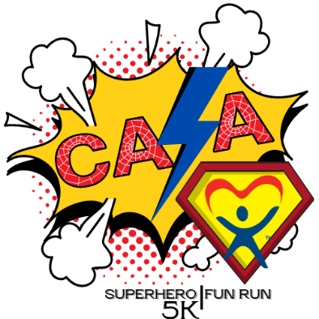

CONQUEROR - $1000
- Recognition announcements throughout the weekend event
- Company Logo displayed on website and media
- Company Logo on event T-Shirts
- Company Name on event signage and print materials
- 10 complimentary race entries for your team
- Opportunity to include an item in runner/participant ditty bags.
- Company name displayed on course day of race.
CHAMPION - $750
- Recognition announcements throughout the weekend event
- Company Logo displayed on website and media
- Company Name on event T-Shirts
- Company Name on event signage and print materials
- 7 complimentary race entries for your team
- Opportunity to include an item in runner/participant ditty bags
SUPERSTAR- $500
- Recognition announcements throughout the weekend event
- Company Logo displayed on website and media
- Company Name on event T-Shirts
- Company Name on event signage and print materials
- 5 complimentary race entries for your team
- Opportunity to include an item in runner/participant ditty bags

HERO- $250
- Recognition announcement throughout the weekend event
- Company Name displayed on website and newsletter
- Company Name on event T-Shirts
- Company Name on event signage and print materials
- 3 complimentary race entries for your team
- Opportunity to include an item in runner/participant ditty bags

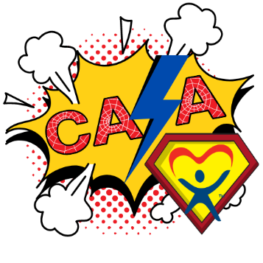
2023 Superhero
5K/1Mile Fun Run
Sponsorship Form

August 12, 2023

Contact & Recognition Information
Company/Individual Name:
(as you wish it to appear) Address (City, Zip):

Phone:
Email:
Fax:
Facebook:

Sponsorship (please circle one):

$1,000 Conqueror $750 Champion $500 Superstar $250 Hero

Race Packet Sponsor (minimum 100 runner/participant ditty bag items)

Secret Sponsorship (protect my identity)

I would like to contribute the amount of $ _____

Other contributions (please specify) _
Please complete and return by July 15, 2023, for recognition on print materials:

Email sponsor forms to 5K@easttexascasa.org Once received, you will be invoiced for your sponsorship!

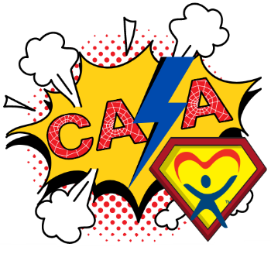
2023 Superhero
5K/1Mile Fun Run
Sponsorship Form
August 12, 2023

This August, we need all our local superheroes to assemble to fight child abuse & neglect at the 2023 CASA Superhero Fun Run! This annual 5k & 1-mile walk/run helps nearly 500 children across Gregg, Rusk & Upshur Counties. East Texas advocates for children who experience abuse and neglect in Gregg, Rusk & Upshur Counties by providing a voice for each child in the court system. Our volunteers work diligently to advocate for the safety of each child we serve. East Texas CASA served 468 children in our community by training volunteer advocates to be the voice for these children. However, we were only able to serve 76% of the children in foster care in our three counties. These children need your help. It costs approximately $1,700 to serve each child and East Texas CASA is committed to providing a voice for every child in our community.

We are activating the Bat Signal and calling on all our superhero sponsors to support this incredible event and our communities’ children. Please review the sponsorship levels on the next page and select the one that fits you best. By sponsoring the CASA Superhero Run, you are helping change children’s lives. You are helping CASA Advocates find relatives for children who thought they were alone, helping keep brothers and sisters together, and helping toddlers find somewhere they can safely and lovingly call “HOME.” You are playing a part in giving kids in our own community a chance to live life. And of course, there are promotional benefits for you as well. Please take a minute to read through the attached materials and decide what level of sponsorship you would like to participate—how many children you would like to help? A $1000.00 sponsorship will make a lifetime difference for children in our three counties.

To support the work of East Texas CASA while raising awareness about child abuse prevention, please join the fight by sponsoring our Superhero Run and family fun to help the children. Each dollar raised makes a difference and we hope you will accept our challenge to move, get involved, make an impact, and help change our communities for the better!

Daniel Peeples Race Chair 5k@EastTexasCASA.org
Chris Derrick Development Director Questions: (903).753.8093

EVERY CHILD NEEDS A HERO, BUT OUR CHILDREN NEED SUPERHEROES!
All proceeds from the Superhero event will benefit East Texas CASA, a registered 501©3 organization.
Donations may be tax-deductible. THANK YOU!

